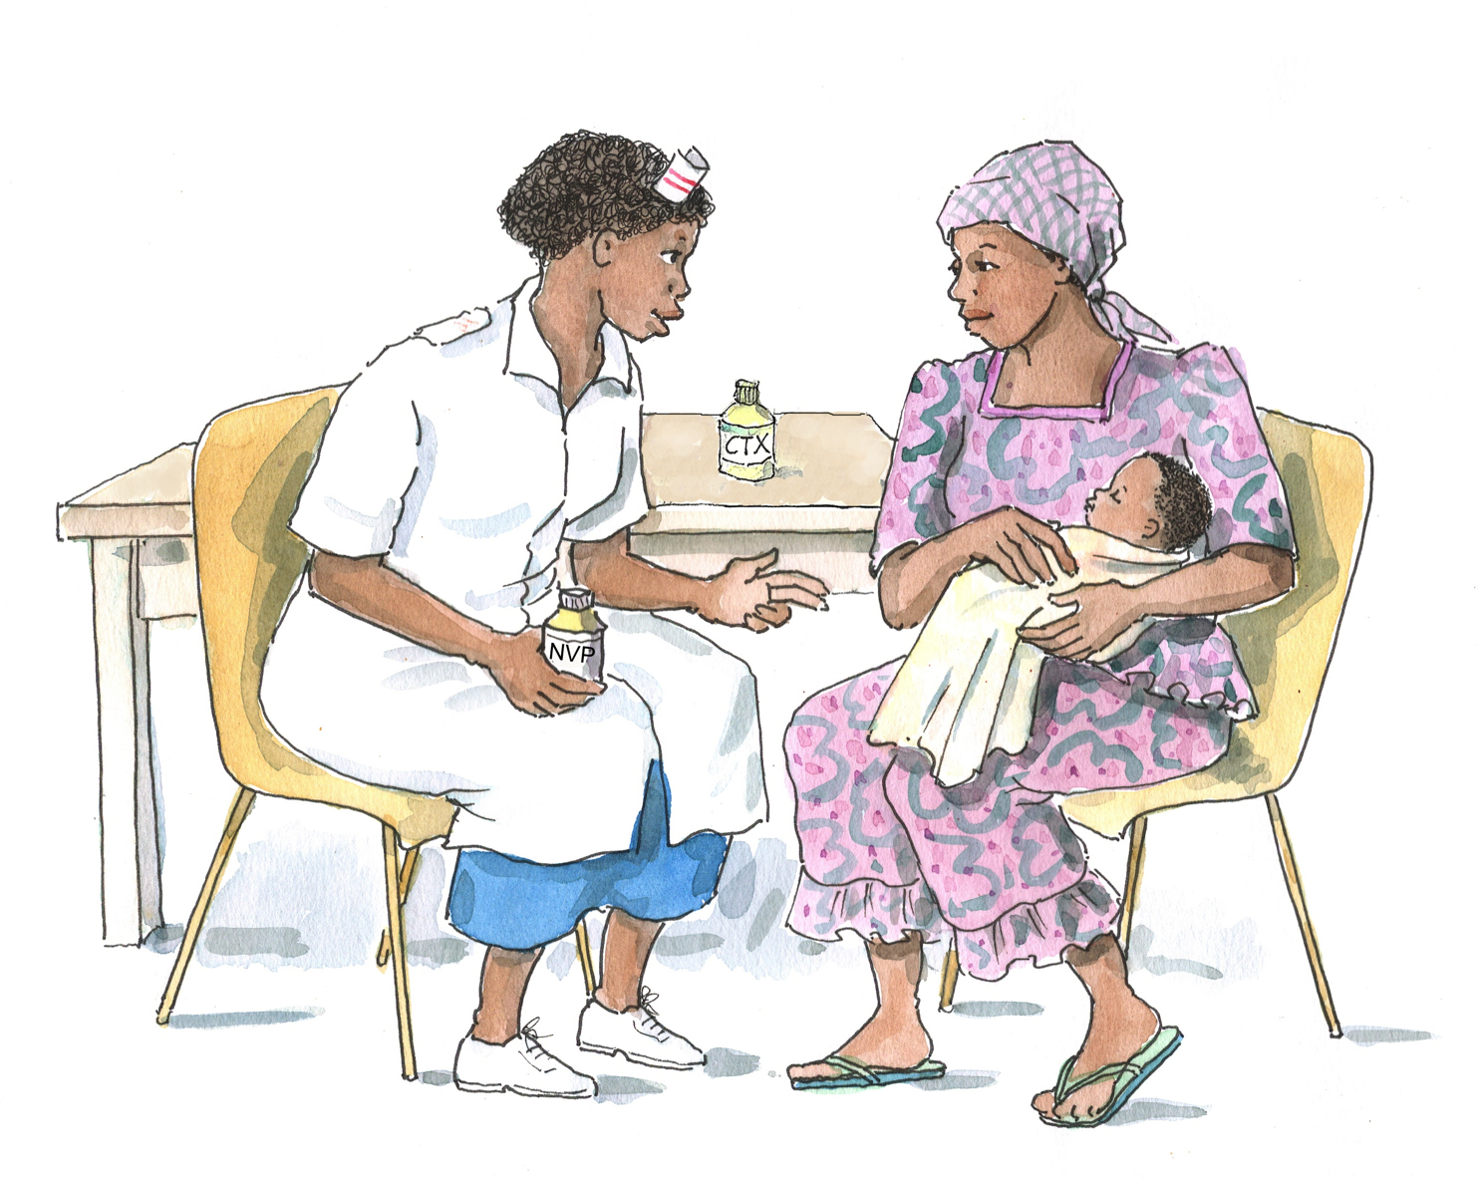
Improving Retention, Adherence, and Psychosocial Support within PMTCT Services

Implementation Workshop Curriculum for
Health Workers

Participant’s Manual
2010

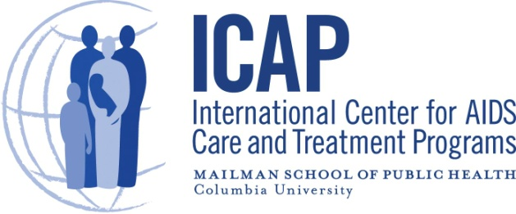

Table of Contents

Module 1: Introduction and PMTCT Update 1-1
Session 1.1: Introductions and Overview of the Workshop 1-2
Session 1.2: PMTCT Update 1-3
Module 2: Retention, Adherence, and Psychosocial Support in PMTCT Programs 2-1
Session 2.1: Retention, Adherence, and Psychosocial Support Basics 2-2
Session 2.2: Improving Retention, Adherence, and Psychosocial Support in PMTCT Programs 2-6
Session 2.3: Case Studies 2-10
Session 2.4: Module Summary 2-13
Module 3: Using the PMTCT Counseling Cue Cards 3-1
Session 3.1: Overview of the PMTCT Counseling Cue Cards 3-2
Session 3.2: Classroom Practicum on Using the PMTCT Counseling Cue Cards 3-4
Session 3.3: Module Summary 3-6
Module 4: Using the PMTCT Checklists, Guides, Forms, and Video 4-1
Session 4.1: Overview of the PMTCT Checklists, Guides, and Forms 4-2
Session 4.2: Practical Session on Using the PMTCT Forms and Guides 4-3
Session 4.3: Orientation to the PMTCT Video 4-5
Session 4.4: Module Summary 4-7
Module 5: Monitoring Retention and Adherence to PMTCT and Planning the Way
Forward 5-1
Session 5.1: Monitoring and Evaluating Retention and Adherence to PMTCT 5-2
Session 5.2: Developing an Action Plan to Roll Out the PMTCT Materials 5-4
Session 5.3: Workshop Evaluation and Closure 5-5
Appendix 5A: Action Plan for Improving Retention, Adherence, and Psychosocial Support within PMTCT Services 5-6
Appendix 5B: Workshop Evaluation Form 5-10
Supplemental Module 6: Review of Counseling and Communication Skills 6-1
Session 6.1: Counseling Basics 6-2
Session 6.2: Key Counseling and Communication Skills 6-5
Session 6.3: Classroom Practicum 6-15
Session 6.4: Module Summary 6-16
Appendix 6A: Counseling and Communication Skills Checklist 6-17
Appendix 6B: Optional Homework/Review of Counseling and Communication Skills 6-18

List of Acronyms

ANC Antenatal care
ART Antiretroviral therapy/treatment
ARV Antiretroviral
CD4 Cluster of differentiation 4 cell
CTX cotrimoxazole
PCR Polymerase chain reaction
HIV Human Immunodeficiency Virus
ICAP International Center for AIDS Care and Treatment Programs
MDT Multidisciplinary Team
NVP nevirapine
PLHIV Person (or people) living with HIV
PMTCT Prevention of mother-to-child transmission (of HIV)
SMS Short message service (text message)
WHO World Health Organization

MODULE 1:
Introduction and PMTCT Update

 | LEARNING OBJECTIVES:  By the end of this Module, participants will be able to:  - Know more about workshop participants and trainers  - Understand the workshop goal, objectives, and agenda  - Discuss changes and updates to the national PMTCT guidelines

 | CONTENT:  Session 1.1: Introductions and Overview of the Workshop  Session 1.2: PMTCT Update

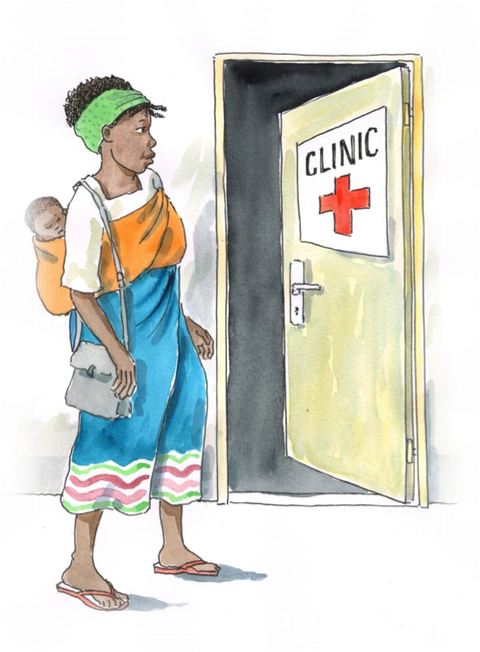

SESSION 1.1:

Introductions and Overview of the Workshop

Implementation Workshop Goal and Objectives

Workshop Goal: This on-site implementation workshop for multidisciplinary team members working in PMTCT settings is intended to improve knowledge, skills, and confidence in improving retention and providing adherence and psychosocial support services throughout the PMTCT spectrum of care.

Workshop Objectives:
By the end of the implementation workshop, participants will be able to:
- Understand changes to the national PMTCT guidelines and how they should be applied in clinical settings.
- Define the PMTCT spectrum of care.
- Define retention, adherence, and psychosocial support in the context of the PMTCT spectrum of care.
- Understand the importance of retention, adherence, and psychosocial support to meet the needs of women and families enrolled in PMTCT services.
- Identify strategies to improve retention, adherence, and psychosocial support within PMTCT programs.
- Use counseling cue cards to conduct ongoing, supportive counseling for pregnant and postpartum women and their family members.
- Use checklists to improve pre- and post-test counseling services for pregnant women, family members, and children.
- Conduct a psychosocial assessment and document key points and next steps, as well as make necessary referrals.
- Use guides to conduct adherence preparation and support sessions with clients and to provide ongoing adherence assessment and follow-up with clients.
- Develop and use an appointment book and appointment reminder cards in PMTCT settings.
- Use a patient education video to reinforce key messages on PMTCT with clients and family members.
- Use improved communication and counseling skills with clients and family members (specific to Supplemental Module 6).

SESSION 1.2:
PMTCT Update

Please see the Slide Set for Module 1.

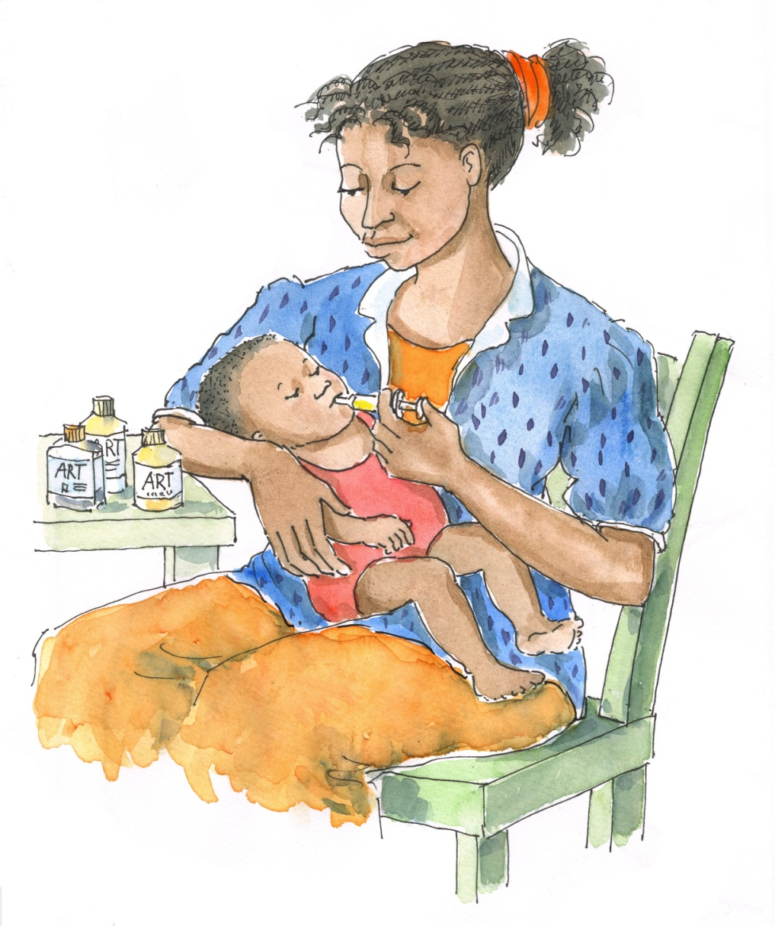

MODULE 2:
Retention, Adherence, and Psychosocial Support in PMTCT Programs

LEARNING OBJECTIVES:
By the end of this Module, participants will be able to:
- Define the terms “retention,” “adherence,” and “psychosocial support”
- Understand the importance of retention, adherence, and psychosocial support in PMTCT programs
- Identify common barriers to retention, adherence, and psychosocial wellbeing among PMTCT clients, including those related to health services
- Identify challenges to providing quality retention, adherence, and psychosocial support services in the PMTCT setting
- Identify strategies to improve retention, adherence, and psychosocial support within the PMTCT program and throughout the PMTCT spectrum of care

CONTENT:
Session 2.1: Retention, Adherence, and Psychosocial Support Basics
Session 2.3: Improving Retention, Adherence, and Psychosocial Support in PMTCT Programs
Session 2.3: Case Studies
Session 2.4: Module Summary

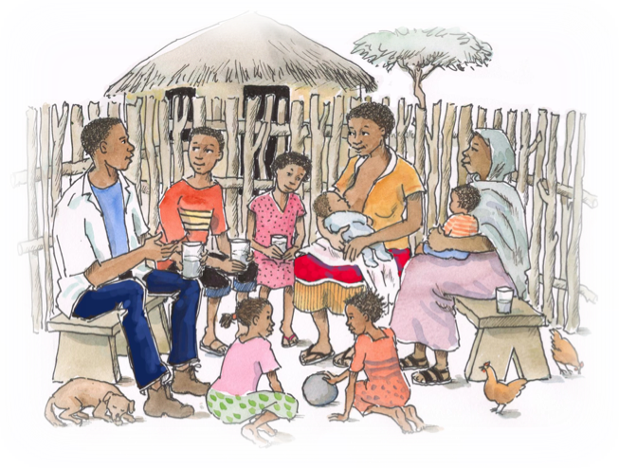

SESSION 2.1:
Retention, Adherence, and Psychosocial Support Basics

Definition of retention:
Retention refers to keeping (or “retaining”) clients in the care program, in this case throughout the spectrum of PMTCT care and services. A goal of all PMTCT programs is to retain women and their babies in the full program of care.
- For women who test positive for HIV, this means that they stay in care during pregnancy and throughout the period of breastfeeding. They are also enrolled in HIV care and treatment, with some women starting lifelong ART and others being monitored for eligibility.
- For HIV-exposed babies, this means staying in care until a final HIV infection status is determined, usually once breastfeeding has ended. For babies who become HIV-infected, this also means enrolling in HIV care services and starting ART as quickly as possible.

Definition of adherence:
The standard clinical definition of adherence has been taking at least 95% of medications the right way, at the right time. Over time, this definition has been broadened to include more factors related to continuous care, such as following a care plan, attending scheduled clinic appointments, picking up medicines on time, and getting regular CD4 tests.
Adherence describes how faithfully a person sticks to and participates in her or his HIV prevention, care, and treatment plan.
Adherence support is an important part of psychosocial support services and PMTCT and HIV clinical care services.

Key concepts of adherence:

Adherence:
- Is not the same as compliance and includes much more than following the doctor’s orders
- Includes active participation of the client in her care plan
- Depends on a shared decision-making process between the client and health care providers
- Includes adherence to both care and to medicines
- Impacts the success of PMTCT and HIV care and treatment programs
- Changes over time

Adherence to PMTCT and HIV care includes:
- Entering into and continuing on a care and treatment plan (sometimes this is also called “retention in care”)
- Taking medicines to prevent and treat opportunistic infections
- Planning for/having a safe delivery in a health facility
- Practicing safer infant feeding practices
- Bringing the baby back often for checkups and for HIV testing at 6 weeks and then again when the baby is weaned.
- Participating in ongoing education and counseling
- Attending appointments and tests (such as antenatal and postnatal appointments and regular CD4 tests) as scheduled
- Picking up medications for self and the child when scheduled, before running out
- Adopting a healthy lifestyle and understanding and minimizing risk behaviors, as much as is possible
- Recognizing when there is a problem or a change in health and coming to the clinic for care and support

Remember: ALL PREGNANT WOMEN LIVING WITH HIV NEED TO TAKE ARVs, THE RIGHT WAY, EVERY DOSE, EVERY DAY!

Adherence to HIV treatment includes:
- Taking ARVs correctly, as prescribed, even if the person feels healthy
- For women who are eligible for ART, taking ARVs as prescribed for their entire life—every pill, every day, for life
- Taking other medicines, such as cotrimoxazole, as prescribed
- Giving medications, including ARVs and cotrimoxazole, to HIV-exposed and HIV-infected babies and children as prescribed
- Not taking any breaks from treatment

Non-adherence to care and treatment includes:
- Missing one or many appointments at the hospital or health center, lab, or pharmacy – for the client or her baby
- Not following the care plan—of the client or her baby—and not communicating difficulties in following the care plan to health workers
- Missing one or more doses of medicine, or not giving the baby doses on time
- Sharing medicines with other people
- Stopping medicine for a day or many days (taking a treatment “break”)
- Taking or giving medicines at different times than recommended by health workers
- Taking or giving medicines without following instructions about food or diet
- Not minimizing risk-taking behavior (for example, not practicing safer sex or not delivering a baby with a trained health care provider). Note that reducing risk-taking often depends on multiple factors and support from others (partner, family), so the ability to do so will depend on the client’s specific situation.
Remember: No one is perfect. It is important not to judge clients if they are non-adherent. Instead, we should try to uncover the underlying causes of non-adherence and help find ways to resume good adherence as soon as possible.

Why is near-perfect adherence to PMTCT and ART medications important?
- To reduce the chance of MTCT at all stages (e.g. during pregnancy, during labor and delivery, during breastfeeding)
- To ensure that ART and other medications do their job and keep clients healthy
- To increase the CD4 cells and decrease the amount of HIV in the body
- To avoid the body becoming resistant to certain medicines
- To make sure the person gets all the benefits that ARVs and other medicines have to offer, such as feeling better, not getting opportunistic infections, etc.
- To monitor the person’s health and also to help her find community support resources for herself and her family
- To keep the person looking and feeling good so that she can get back to normal life
- To keep families, communities, and our nation healthy and productive

What happens when a person doesn’t adhere to his or her care and treatment plan?
- The levels of drugs in the body drop and HIV keeps multiplying.
- A baby is more likely to acquire HIV from his or her mother during pregnancy, delivery, or breastfeeding.
- The CD4 count will drop and the person will start getting more opportunistic infections.
- Children in particular will become ill very quickly.
- It is more likely that the person will pass HIV to others (during unprotected sex, for example).
- The person might become depressed or de-motivated due to illness or physical deterioration.
- The person can develop resistance to one or all of the drugs, meaning that the drugs will not work anymore even if they are taken correctly again. We can say that HIV is a very “smart” virus—it only takes a couple of missed doses for it to learn how to be stronger than the ARVs, to multiply, and to take over the body again.
- The person may have to start taking a new regimen or second-line ARVs. In many countries, there aren’t many kinds of ARVs available, so individuals with poor adherence may run out of medication options.
Definition of psychosocial support:
Psychosocial support addresses the ongoing psychological and social concerns and needs of people living with HIV (PLHIV), their partners, their family, and caregivers of children living with HIV. In the context of PMTCT services, psychosocial support addresses the psychological, social, and adherence needs of pregnant and postpartum women, their partners and families, and children throughout the spectrum of PMTCT care.
Remember: Since pregnancy is a relatively short period of time, it is very important to assess and support pregnant women’s psychosocial support needs as soon as they are enrolled in ANC and PMTCT services.

It is important to provide psychosocial support to pregnant women and family members because:
- HIV affects all dimensions of a person’s life: physical, psychological, social, and spiritual.
- A woman who has just learned her HIV-status during prenatal HIV testing may need support in understanding and adjusting to this information, as well as planning what is going to happen next.
- It can help clients and caregivers cope more effectively with HIV and enhance their own and their children’s quality of life.
- It can help facilitate the disclosure process.
- It can create opportunities to provide pregnant women and their families with needed information, specific to their situation.
- It can help clients gain confidence in themselves and their skills (coping with chronic illness, dealing with stigma or discrimination, adhering to the care and treatment plan, dealing with taking/giving medications every day, caring for an HIV-exposed or HIV-infected child, etc.).
- It can help build a trusting relationship between the client and the health worker.
- It can sometimes prevent more serious mental health issues from developing (like anxiety, depression, or withdrawal).
- Psychosocial wellbeing is related to better adherence to PMTCT and HIV care and treatment.
- Mental health is closely linked to physical health and wellbeing.
- It can provide people (or link people) with needed social, housing, and legal services.
- It can help people mentally and practically prepare for difficult circumstances, like ill health, having an HIV-infected baby, etc.
- When people can come together to solve problems and support one another, movements for change, acceptance, and advocacy are born.
Retention, adherence, and psychosocial support are interrelated. A client is more likely to be retained in PMTCT care and adhere to her own and her baby’s care and treatment if she receives ongoing information, education, and support at the clinic, in the community, and at home.

SESSION 2.2:
Improving Retention, Adherence, and Psychosocial Support in PMTCT Programs

Why don’t clients stay in care and adhere to care and treatment?
- Most clients want to adhere to their own and their baby’s care and treatment, but many times there are barriers that make this a challenge.
- Some of the barriers have to do with the client herself, her family situation, or characteristics of her community.
- Often, the health system itself creates challenges to retention, adherence, and psychosocial wellbeing.
- While the focus of this curriculum is not on these issues per se, they are extremely important and all health workers play a role in trying to make the system better as an individual and as part of a program.
- Retention, adherence, and psychosocial wellbeing can be improved when the client has clear information and practical guidance about her own and her baby’s care and medications, as well as other aspects of PMTCT, such as safe infant feeding.
- It is important for health workers to have all of the information and present it to the client and her family using good counseling and communication skills and in ways that are easy to understand.

Factors affecting retention, adherence, and psychosocial wellbeing
Factors about health services (note that as health workers, these are the factors that we have the most control in addressing and minimizing):
- Health worker attitudes
- Health worker language abilities
- Time available for individual counseling
- Space available for individual counseling
- Skills of counselors and other service providers
- Multidisciplinary approach to supporting adherence and psychosocial wellbeing
- Availability of tools to support quality counseling
- Standard procedures to assess and counsel on adherence at every visit
- PLHIV involvement in service delivery
- Drug stock-outs
- Distance to the clinic/transportation costs
- Convenience of clinic hours
- Patient record and tracking systems
- Number and type of health workers
- Youth-friendliness of services
- Waiting times
- Linkages between different services
- Referral systems
- Linkages to community services and support
- Support groups

Factors about individual people:
- How well they think they can adhere
- Acceptance of HIV-status
- Ability to disclose
- Acceptance of HIV-status and level of support from family
- Having a treatment supporter
- Understanding the benefits of HIV care and treatment and PMTCT services
- Quality of life while on treatment
- How sick or well people feel
- Travel and migration
- Health status
- Mental illness, like depression
- Drug or alcohol abuse
- Concern for the family’s wellbeing

Factors about our communities and our culture:
- Poverty
- Lack of food
- Stigma
- Social support at home and in the community
- Access to correct information
- Lack of childcare to attend clinic
- Ability to take time off work to attend clinic
- Family structure and decision-making
- Gender inequality
- Violence
- Forced migration
- Distrust of the clinic/hospital
- Use of traditional medicine
- Political instability or war
- Physical environment, e.g., mountainous, seasonal flooding, etc.

Factors about medicines:
- Side effects
- Number of pills in regimen
- Dose timing
- Need to take with food
- Availability of reminder cues—pill boxes, calendars, alarms, etc.
- Taste
- Changing pediatric doses
- Changes in drug supplier—changes in labeling, pill size, color, formulation
- Portability of medicines, especially syrups

The PMTCT Care Spectrum for Women

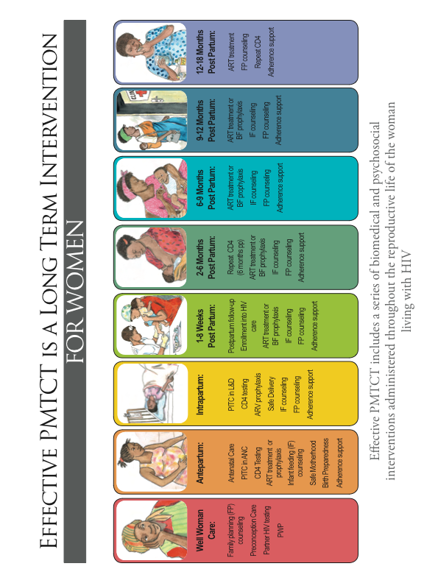

The PMTCT Care Spectrum for CHILDREN

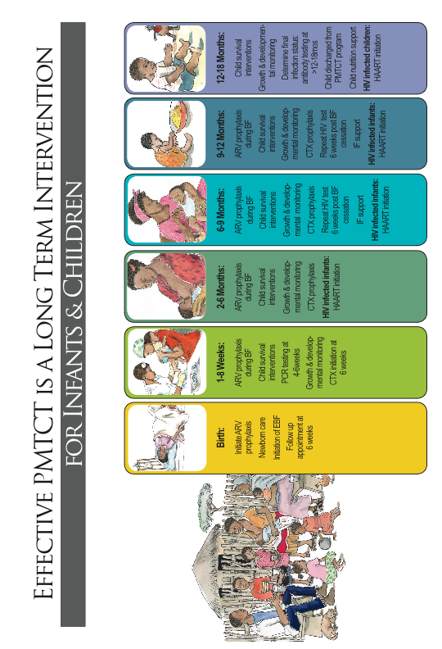

SESSION 2.3:
Case Studies

Case Studies

Case Study 1:
P___ is 18 years old, pregnant, and tested positive for HIV during her first ANC visit. During your session with P___, she discloses that it will be difficult for her to take medicines because she can’t disclose to anybody. She expresses her fears of her boyfriend throwing her out of the house and not supporting her, but she really wants to protect her unborn baby.

Questions:
- What are the most important issues for P___ right now?
- What kind of psychosocial support do you think P___ needs?
- What kind of adherence support does P___ need?
- What would your plan be for the current session with P___? What would you discuss?
- How would you document your session and the next steps you agree upon with P___?
- What roles would different members of the multidisciplinary team take in P___’s care and counseling?
- What tools would help you, the health worker, provide quality counseling and care to P___?
- Would you provide any referrals for P___? If yes, describe. How would you document this and find out if she went where she was referred?

Case Study 2:
N___ is married and has 4 children. She is 5 months pregnant and at her last ANC visit she was referred to the ART clinic because her CD4 count was 200. She missed her next ANC visit, but returns to the clinic a few weeks later. When you meet with her, N___ says that she went to the ART clinic, but left because there was a long queue and people were gossiping about her. She decided she does not want to take any ARV medications and is feeling fine.

Questions:
- What are the most important issues for N___ right now?
- What kind of psychosocial support do you think N___ needs?
- What kind of adherence support does N___ need?
- What would your plan be for the current session with N___? What would you discuss?
- How would you document your session and the next steps you agree upon with N___?
- What roles would different members of the multidisciplinary team take in N___’s care and counseling?
- What tools would help you, the health worker, provide quality counseling and care to N___?
- Would you provide any referrals for N___? If yes, describe. How would you document this and find out if she went where she was referred?

Case Study 3:
M___ delivered her baby, a girl, 9 weeks ago. M___ took ARVs during her pregnancy and delivered at a health facility. She missed her 6-week postpartum visit, but comes to the clinic a couple of weeks later for a well-child visit. The baby was given ARVs at birth, but M___ said she has not been able to give the baby medications at home because she doesn’t want her family to be suspicious. Right now, neither the baby nor M___ is taking any medications. The baby doesn’t seem to be gaining very much weight even though M___ says she breastfeeds often.

Questions:
- What are the most important issues for M___ right now?
- What kind of psychosocial support do you think M___ needs?
- What kind of adherence support does M___ need?
- What would your plan be for the current session with M___? What would you discuss?
- How would you document your session and the next steps you agree upon with M___?
- What roles would different members of the multidisciplinary team take in M___’s care and counseling?
- What tools would help you, the health worker, provide quality counseling and care to M___?
- Would you provide any referrals for M___? If yes, describe. How would you document this and find out if she went where she was referred?

SESSION 2.4:
Module Summary


The key points of this Module include:
- Retention refers to keeping clients (and their babies) in the care program, throughout the spectrum of PMTCT care.
- Adherence means how faithfully a person sticks to, and participates in, her or his HIV care and treatment plan.
- Adherence to PMTCT and HIV care is important to make sure women and babies stay healthy, get the ongoing care they need, understand how to live positively, know when and how to start ARVs or ART, and get psychosocial support.
- Adherence to medications is important to lower the amount of HIV in the body, to lower the chances that the baby will acquire HIV, and to make sure women and babies get all the benefits that ARVs and other medicines have to offer for their own health.
- Psychosocial support addresses the ongoing psychological and social concerns and needs of people living with HIV, their family, and caregivers of children living with HIV.
- Retention, adherence, and psychosocial support are interrelated. A client is more likely to be retained in PMTCT care and adhere to her own and her baby’s care and treatment if she receives ongoing information, education, and support at the clinic, in the community, and in her family.
- There are many barriers and challenges to retention, adherence, and psychosocial wellbeing, including things related to people’s lives, to our culture, to the health care program, and to the medicines themselves.
- Retention, adherence, and psychosocial support are important services in PMTCT programs and throughout the PMTCT spectrum of care—from the time before a woman gets pregnant, through her pregnancy and delivery, the postpartum period, weaning, and until there is a final infection status for the child.
- The entire multidisciplinary team is responsible for providing retention, adherence, and psychosocial support to pregnant and postpartum women.

MODULE 3:
Using the PMTCT Counseling Cue Cards

LEARNING OBJECTIVES:
By the end of this Module, participants will be able to:
- Understand why the PMTCT counseling cue cards were developed and how they can be used by health workers
- Discuss how the PMTCT counseling cue cards could be used in their clinic setting
- Be familiar with the key messages in each of the counseling cue cards
- Use the PMTCT counseling cue cards as an aide/guide when working with clients in various stages of the PMTCT care spectrum

CONTENT:
Session 3.1: Overview of the PMTCT Counseling Cue Cards
Session 3.2: Classroom Practicum on Using the PMTCT Counseling Cue Cards
Session 3.3: Module Summary

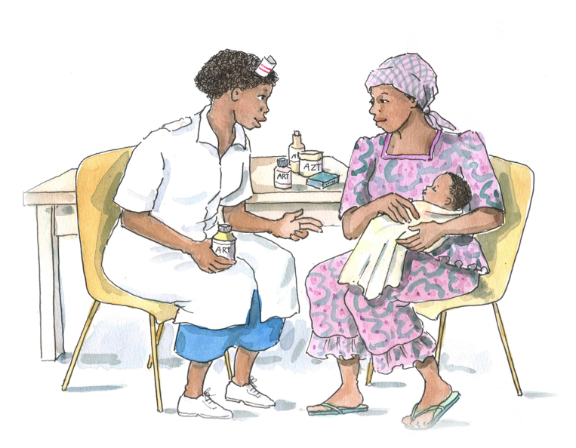

SESSION 3.1:
Overview of the PMTCT Counseling Cue Cards

How to Use the Counseling Cue Cards
The counseling cue cards were developed to support a range of providers who work with pregnant women living with HIV and their families.
Good counseling and communication skills, such as active listening, being attentive to the client’s questions and needs, and avoiding one-way communication, should always be used, no matter what the counseling topic.
Each of the cards focuses on a specific topic important to the care and support of pregnant women living with HIV, their children, and families across the PMTCT continuum of care. Providers may use the cue cards as job aides and reminders of key information to cover during initial post-test and ongoing counseling sessions with pregnant women and newly delivered mothers, their partners, family members, and supporters. The cue cards do not have to be used in sequence, but instead should be used according to the client’s specific needs and concerns during the session.

Counseling Cue Card Topics:
- PMTCT Basics
- Staying Healthy During Your Pregnancy
- Adhering to Your PMTCT Care Plan
- Preparing to Start and Adhere to Lifelong ART
- Continuing and Adhering to ART During Pregnancy
- Preparing to Start and Adhere to AZT Prophylaxis
- Preparing to Start and Adhere to ART Prophylaxis
- HIV Testing for Your Partner and Family Members
- Disclosing Your HIV-Status
- Being Part of a Discordant Couple
- Having a Safe Labor and Delivery
- Taking Care of Yourself After Your Baby is Born
- Caring for Your HIV-Exposed Baby and Adhering to Care and Medicines
- Safely Feeding Your Baby
- Exclusively Breastfeeding Your Baby
- Exclusively Replacement Feeding Your Baby
- Introducing Complementary Foods to Your Child at 6 Months
- Making Decisions About Future Childbearing and Family Planning
- Testing your Baby or Child for HIV
- Caring for Your HIV-Infected Baby or Child and Adhering Care and Medicines

Please note:
- Key questions are included in italics, and may be used to initiate discussions, learn more about what the client already knows and her specific concerns, and to gauge understanding and elicit follow-up questions.
- Notes to guide counselors are also included in italics.
- The margins of each card contain cross-references to other cards on relevant topics (for example, if infant feeding is mentioned, there will be a cross-reference to the specific cue cards addressing infant feeding to which the provider may want to refer).

SESSION 3.2:
Classroom Practicum on Using the PMTCT Counseling Cue Cards

Case Studies:

Case Study 1:
N___ is 14 weeks pregnant and just came to the antenatal clinic for her first visit. You deliver the news that her HIV test was positive and provide post-test counseling. After talking with her, you sense that she does not have very much information on PMTCT. Counsel N___ on the key things she needs to know about PMTCT and having a healthy pregnancy.
(see PMTCT Basics, Staying Healthy During Your Pregnancy, HIV Testing for Your Partner and Family Members, and Adhering to Your PMTCT Care Plan cue cards)

Case Study 2:
J___ is enrolled in the PMTCT program and will begin prophylaxis now that she is 14 weeks pregnant (and her CD4 count is 500). Counsel her on adherence to her PMTCT care plan and her prophylaxis regimen. Also talk with her about planning to have a safe labor and delivery.
(see Adhering to Your PMTCT Care Plan, Preparing to Start and Adhere to AZT or ART Prophylaxis [depending on national guidelines], and Having a Safe Labor and Delivery cue cards)

Case Study 3:
L___ is enrolled in the PMTCT program. She began taking ART about one month ago, but complains that she is not feeling well and says that she wants to stop taking the medicine. Counsel L___ on having a healthy pregnancy, on why ART is important, and on how she can adhere to her care plan and ART.
(see Adhering to Your PMTCT Care Plan, Preparing to Start and Adhere to Lifelong ART, and Staying Healthy During Your Pregnancy cue cards)

Case Study 4:
T___ has been on ART for about 3 years and her CD4 count is high. You meet her at the ANC clinic, where she is enrolled in the PMTCT program. She is worried that the ART she has been taking will hurt her baby. Counsel T___ on adherence to her PMTCT care plan and ART, and also on how she can safely breastfeed her baby once he or she is born.
(see Adhering to Your PMTCT Care Plan, Continuing and Adhering to Your ART During Pregnancy, and Safely Feeding Your Baby – Breastfeeding cue cards)

Case Study 5:
A___ tests positive for HIV at her first antenatal visit. She is shocked and says she’s only ever had sex with her husband. She has 2 other young children at home, but A___ says she has never thought about testing them for HIV since they are healthy. She is afraid to talk to her husband about her test result and says she will just keep it to herself. Counsel A___ on PMTCT basics, as well as on HIV testing for her husband and children, and disclosure to someone she trusts.
(see PMTCT Basics, HIV Testing for Your Partner and Family Members, and Disclosing Your HIV-Status cue cards)

Case Study 6:
M___ found out that she is HIV-infected 7 months ago, while she was pregnant. She just gave birth to a baby girl and doesn’t think it’s safe for her to breastfeed the baby. She is willing to do anything to make sure her daughter remains HIV-uninfected. However, she also has to return to work soon and has 2 other children to support. M___ has not told her boyfriend about her or the baby’s HIV-status. Counsel M___ on taking care of herself, talking with her partner, and caring for her HIV-exposed daughter.
(see HIV Testing for Your Partner and Family Members, Disclosing Your HIV-Status, Taking Care of Yourself After Your Baby is Born; Caring for Your HIV-Exposed Baby and Adhering to Care and Medicines; Exclusively Breastfeeding Your Baby; and Testing Your Baby or Child for HIV cue cards)

Case Study 7:
B___ is a client in the PMTCT program. She gave birth to her son about 2 months ago. She missed the baby’s 6-week follow-up appointment, but returns to the clinic 2 weeks later. B___ is breastfeeding her son, but complains that her nipples are very sore. B___’s family does not know she is HIV-infected and she is having trouble remembering to give her baby nevirapine. Counsel B___ on disclosure, adherence to care and medicines for her HIV-exposed baby, HIV testing for the baby, and also on safely feeding her baby.
(see Disclosing Your HIV-Status, Caring for Your HIV-Exposed Baby and Adhering to Care and Medicines; Exclusively Breastfeeding Your Baby; and Testing Your Baby or Child for HIV cue cards)

Case Study 8:
P___ returns for her 8-week old baby’s HIV test results. The results show that the baby is HIV-uninfected. P___ is exclusively breastfeeding her baby and taking lifelong ART. P___ is very happy about the results and says she thinks she should stop breastfeeding immediately since her baby is negative. Counsel P___ on caring for her HIV-exposed baby, safe breastfeeding and when to retest the baby, and on being part of a discordant couple.
(see Caring for Your HIV-Exposed Baby and Adhering to Care and Medicines; Exclusively Breastfeeding Your Baby; and Testing Your Baby or Child for HIV cue cards)

Case Study 9:
C___ is a client in the PMTCT program and is taking lifelong ART. She recently delivered a healthy baby boy, who tested HIV-negative at 6 weeks. C___ comes back to the clinic for a checkup. She says she really wants to have another child in a couple of years, but that her husband does not think it’s worth the risk of the baby being HIV-infected. C___’s husband is HIV-uninfected. Counsel C___ on how she can make safe decisions about having children in the future, how she can prevent or space pregnancies now, and about being part of a discordant couple.
(see Making Decisions About Future Childbearing and Family Planning and Being Part of a Discordant Couple cue cards)

Case Study 10:
V___ is the primary caregiver of her 8-month old nephew, who has been sick a lot and is not gaining weight. She is shocked to learn that the baby is HIV-infected and had no idea that her sister was HIV-infected. She feels frustrated because she already is caring for her own children and doesn’t have much money or time to keep bringing her nephew to the clinic. Counsel V___ on caring for her HIV-infected nephew, including on adherence to care and medicines.
(see Caring for Your HIV-infected Child and Adhering to Care and Medicines cue card)

SESSION 3.3:
Module Summary

THE KEY POINTS OF THIS MODULE INCLUDE:

- All health workers should be up-to-date and knowledgeable about their national PMTCT guidelines.
- Pregnant and postpartum women and caregivers of HIV-exposed and HIV-infected babies and children often have a number of retention, adherence, and psychosocial support needs that may change over time.
- Quality communication and counseling in the PMTCT setting can lead to increased retention, adherence, and psychosocial wellbeing among clients.
- Health workers can use counseling cue cards to help explain the basics of PMTCT care and remember key counseling messages for clients in different places along the PMTCT care spectrum.
- Each clinic should have a specific plan on how the counseling cue cards are used (who, when, where, how, etc.).
- Counseling is a part of everyone’s job and all multidisciplinary team members should be familiar with and have copies of the counseling cue cards.
- When talking with clients, it is always important to use the 7 key counseling and communication skills (discussed in Supplemental Module 6).

MODULE 4:
Using the PMTCT Checklists, Guides, Forms, and Video

LEARNING OBJECTIVES:
By the end of this Module, participants will be able to:
- Discuss the importance and relevance of each of the PMTCT Tools within the Toolkit
- Conduct pre-test and post-test education and counseling sessions with clients, using structured checklists
- Conduct a psychosocial assessment and fill in the psychosocial assessment reporting form
- Conduct and document adherence preparation and support counseling with clients, using a guide and reporting form
- Conduct and document adherence assessments and follow-up counseling with clients, using a guide and reporting form
- Discuss the importance of having an appointment system in PMTCT settings and how to use an appointment book and appointment reminder cards
- Describe how each PMTCT Tool might be applied in their specific clinic setting
- Discuss how to use the PMTCT video in their clinic and/or community settings

CONTENT:
Session 4.1: Overview of the PMTCT Checklists, Guides, and Forms
Session 4.2: Practical Session on Using the PMTCT Forms and Guides
Session 4.3: Orientation to the PMTCT Video
Session 4.4: Module Summary

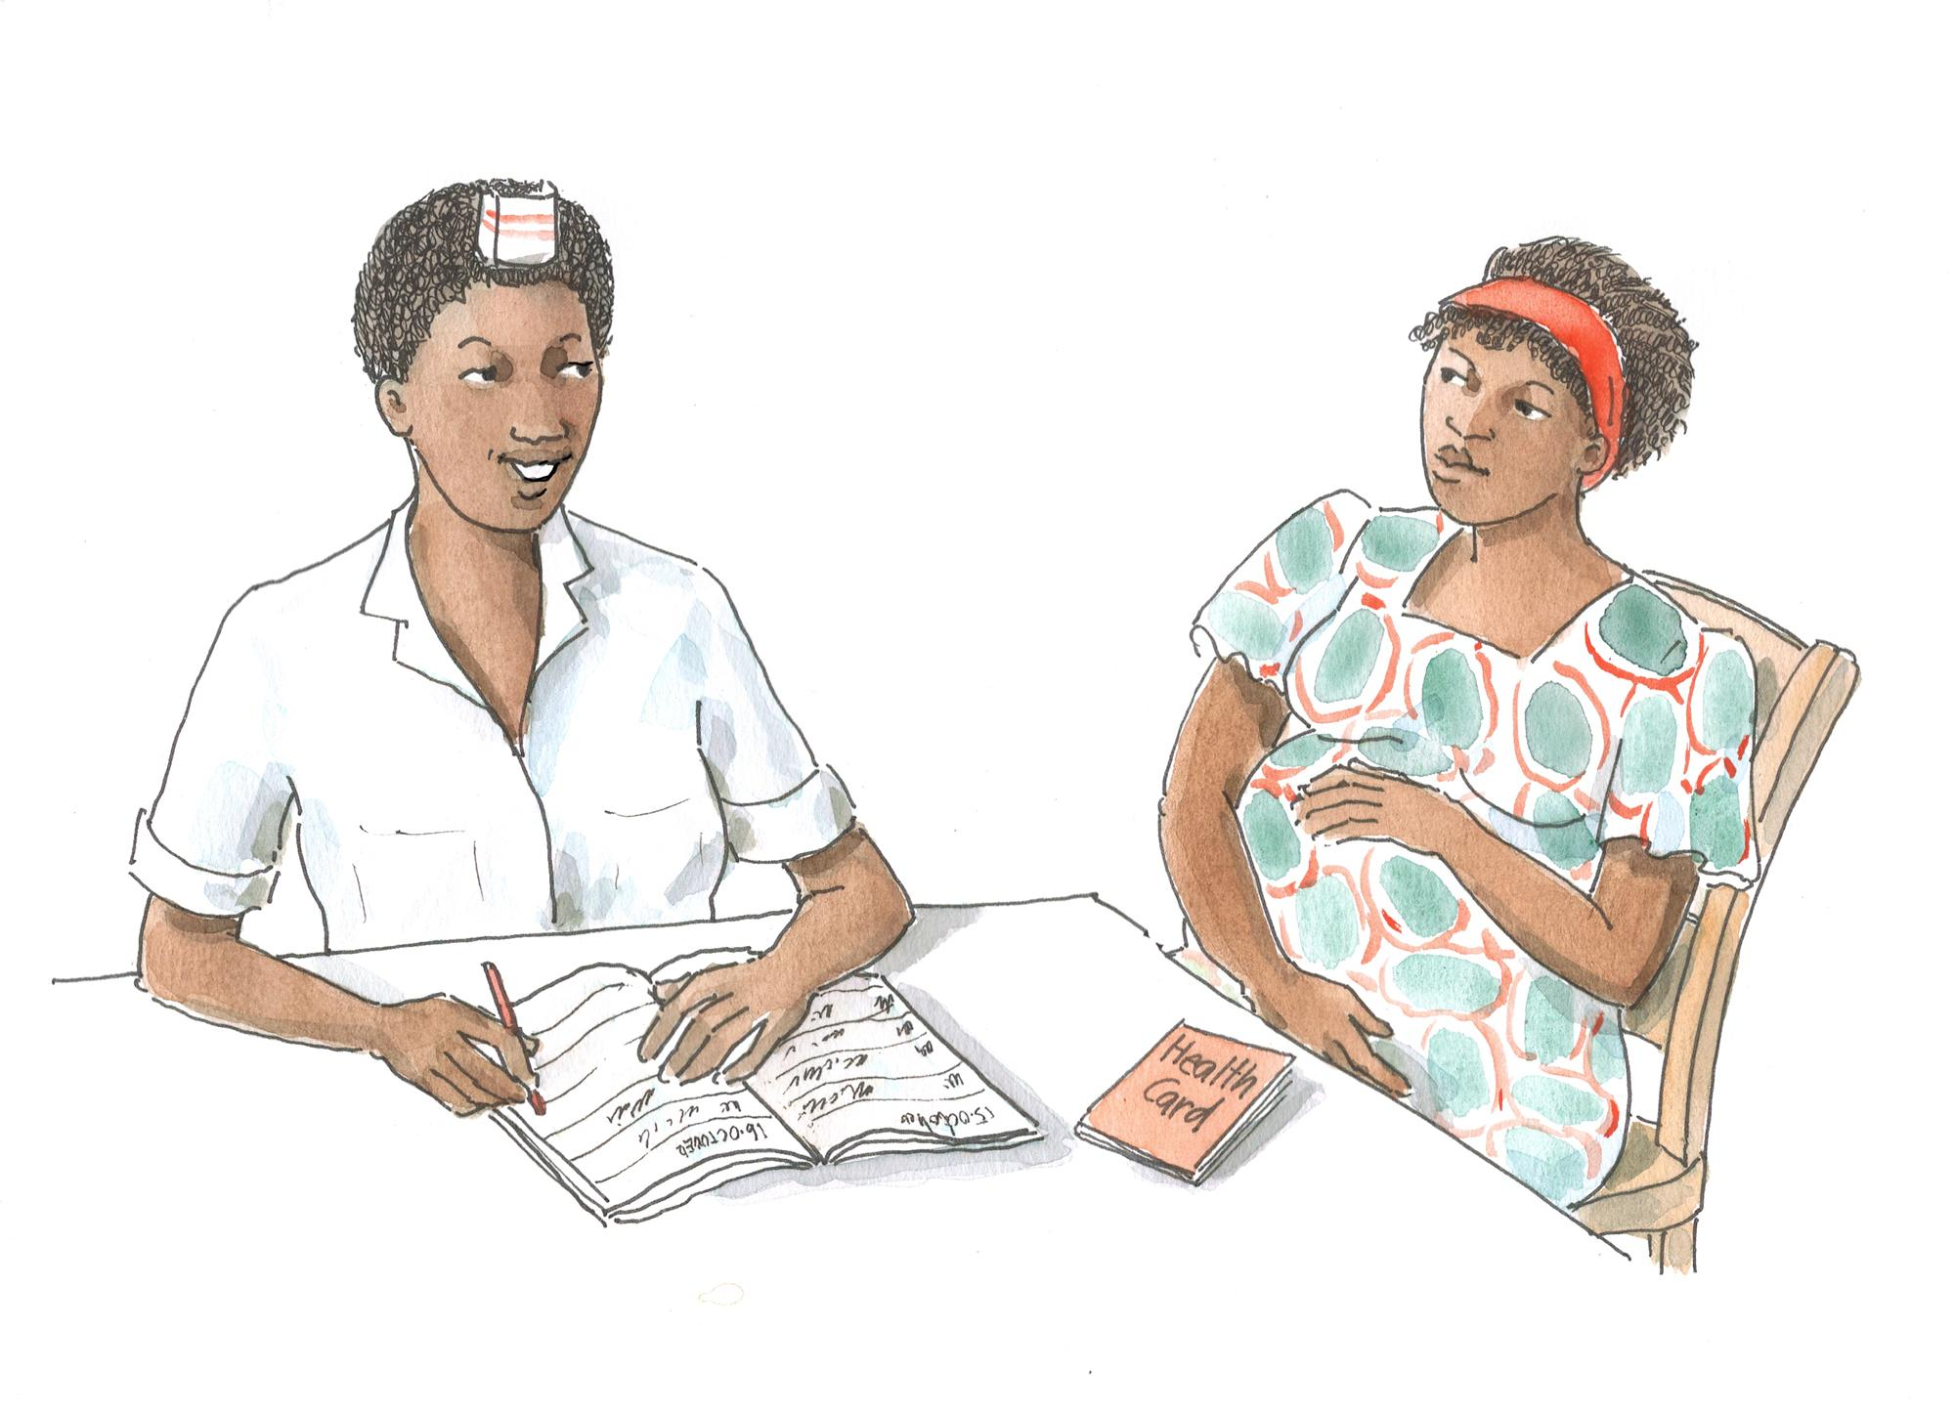

SESSION 4.1:
Overview of the PMTCT Checklists, Guides, and Forms

Please see the “How to Use…” sections and individual tools in the Toolkit for more information.

There are 5 sets of forms and guides in the Toolkit:
Pre-test information and education sessions and individual post-test counseling should be conducted with clients.
- PMTCT Pre- and Post- HIV Test Counseling Checklists to be used by health workers when providing pre- and post- test counseling to PMTCT clients

- A PMTCT Psychosocial Assessment Guide and Reporting Form to be used by health workers when conducting initial and follow-up psychosocial assessments with PMTCT clients
It is recommended that a psychosocial assessment be conducted with all clients upon entry into the PMTCT program.

Initiation of ARVs or ART among pregnant women should NOT be delayed for any reason. Basic adherence preparation should be conducted in 1 visit (if possible) and follow-up adherence counseling provided at each subsequent clinic visit.

- Adherence Preparation and Support Guides to be used by health workers to help clients prepare to adhere to their own (and their baby’s) care and treatment plans and when providing ongoing adherence support

Adherence should be assessed at each clinic visit and ongoing counseling and support provided throughout the PMTCT spectrum of care.

- Adherence Assessment and Follow-up Guides to be used by health workers to assess adherence and learn more about adherence challenges the client may be facing, as well as to provide ongoing adherence support

Functional appointment systems are the cornerstone of retention and adherence to PMTCT care. All clinics should have an appointment system, including systematic follow-up of clients who miss appointments.

- Appointment Book and Appointment Reminder Card Templates to be adapted and implemented at the clinic level in order to help keep track of appointments and to help trace clients lost to follow-up, as well as to help clients keep track of upcoming appointments

SESSION 4.2:
Practical Session on Using the PMTCT Forms and Guides

Case Studies for Each of the 5 Tools:

- Counseling checklists for HIV testing in antenatal care settings
Part A:
You are leading a group pre-test information session for pregnant women at the clinic. What would you say in the session? Use the checklist as a guide.

Part B:
O___ is a pregnant woman coming for her first antenatal appointment. She received HIV testing and her results are negative. Provide O___ with post-test counseling. Use the checklist as a guide.

Part C:
F___ is a pregnant woman who decided to be tested for HIV at her second antenatal visit. Her test results are positive. Provide F___ with post-test counseling. Use the checklist as a guide.

- Psychosocial assessment guide and recording form
Part A:
G___ is a newly enrolled PMTCT client. Conduct a psychosocial assessment with G___. Be sure to complete the psychosocial assessment recording form.

Part B:
W___ is a client in the PMTCT program. She delivered a baby girl 6 weeks ago and has returned to the clinic for the 6-week checkup. Conduct a psychosocial assessment with W___. Be sure to complete the psychosocial assessment recording form.

- Adherence preparation and support guides
Part A:
F___ is 14 weeks pregnant and her CD4 count is 650, so she will be starting PMTCT prophylaxis. Counsel and prepare F___ on adherence to her care and the ARVs that she will be given today. Use the appropriate Adherence Preparation and Support Guide, being sure to take notes on the form.

Part B:
S___ is pregnant and just started taking lifelong ART 2 weeks ago. Counsel and prepare S___ on adherence to her care and ART. Use the appropriate Adherence Preparation and Support Guide, being sure to take notes on the form.

Part C:
P___ goes for her first visit at the antenatal clinic. She has been taking ART for the last 3 years and is excited to have a baby. Counsel her on adherence to ART during her pregnancy and for life. Use the appropriate Adherence Preparation and Support Guide, being sure to take notes on the form.

Part D:
X___ is the primary caregiver of her sister’s 1-month old baby. The baby, named C___ is HIV-exposed. Counsel X___ on adherence to the baby’s care and medicines. Use the appropriate Adherence Preparation and Support Guide, being sure to take notes on the form.

- Adherence assessment and follow-up guides
Part A:
R___ returns for her monthly antenatal visit and ARV refill. Assess R___’s adherence and provide follow-up adherence counseling and support.

Part B:
H___ is caring for her 3-month old baby, who is HIV-exposed and breastfeeding. The baby’s 6 week PCR test was negative. They return for a checkup and medication refill. Assess H___ and the baby’s adherence and provide follow-up adherence counseling and support.

- Appointment book and appointment reminder card templates
Part A:
B___ is a PMTCT client. She needs to make a follow-up appointment for an ARV refill and checkup. Make a follow-up appointment with B___ being sure to fill in the appointment book and to give her an appointment reminder card to take home.

Part B:
I___ is a PMTCT client that was scheduled to come in for a checkup and refill on Monday. It is now Friday and I___ has not come to the clinic. How would you complete the appointment book and what next steps would you take?

SESSION 4.3:
Orientation to the PMTCT Video

How to Use the PMTCT Patient Education Video:
“Saving Two Lives: A Patient Education Video on Adherence to PMTCT” was created to reinforce key PMTCT messages with clients, their family members, caregivers, and community members. The video was filmed in Port Elizabeth, South Africa and most of the actors are actual nurses, peer educators, mother mentors, and community members from the area.

The video was developed as a generic product, so while it may not completely reflect the specifics of PMTCT care in all countries, it is still useful in promoting the key concepts of PMTCT, including retention, adherence, and the importance of psychosocial support. The video is in English, so careful facilitation is especially required in settings where viewers do not use English as a first language.

The video is divided into specific scenes. It may be played in its entirety, or by section, depending on the time available and the audience.
- In the first scene, the viewer is introduced to Hope, a young woman who lives with her husband and mother-in-law. Hope goes to the clinic for her first ANC visit (despite her mother-in-law’s insistence that this is a waste of time), where she is tested for HIV, and learns that she is HIV-infected. The nurse at the clinic gives Hope information on the meaning of her test results and how she can prevent MTCT. Afterwards, Hope meets an experienced mother and PMTCT client, Janet, who gives her information and support on what she needs to do to prevent MTCT.
- In the second scene, Janet returns to the clinic with Hope one week after they met. Hope picks up her CD4 test results and prepares to start taking ARVs. The nurse and Janet give Hope practical advice on how she can lower the chances that her baby will be HIV-infected, including the importance of adherence to her PMTCT care plan and medicines.
- In the third scene, we see Hope and her newborn baby attend a mother’s support group meeting in the community. Hope shares some of her experiences caring for her HIV-exposed baby and learns more from other support group members and the Peer Educator who is facilitating the meeting.
- Each scene is separated by “commercials” that reiterate key messages on PMTCT.

The video may be used in a number of settings, including:
- In the ANC waiting area, if there is a TV and DVD/VCD player
- As part of group education sessions with PMTCT clients
- As part of individual counseling and education sessions with PMTCT clients
- As part of training and mentoring activities for lay counselors, peer educators, mother mentors, etc.
- In support group meetings
- In the community, for example at community meetings, religious gatherings, workplaces, marketplaces, and other venues where people come together
- In women’s and youth group activities
- In PLHIV association activities
- As part of a public service announcement (PSA) on television

The video will be most effective if a health worker (nurse, peer educator, counselor, etc.) facilitates the video with viewers.
- Once programs decide on how and where the video will be used, it is recommended that tailored facilitation guides, including prompts and questions, be developed and implemented.
- For example, if the video is used as part of a group education session with PMTCT clients, the facilitator could stop the video at regular intervals and ask clients what they think is happening, what they think the characters are feeling, and how the situation shown in the video relates to their own PMTCT care and medicines. Similar questions can be asked at the end of the video in cases where the entire video is shown at once.
- Facilitation and guided discussion will also allow for more in-depth discussion of PMTCT care and medicines, for example discussing which specific ARVs pregnant women and HIV-exposed children take and for how long, specific examples of adherence challenges and reminders, and ways to safely feed and care for HIV-exposed infants.
- As mentioned above, guided facilitation will also help viewers understand what is happening in the video, especially if they do not speak/understand English as a first language.

SESSION 4.4:
Module Summary
THE KEY POINTS OF THIS MODULE INCLUDE:
- All health workers should be up-to-date and knowledgeable about their national PMTCT guidelines.
- Pregnant and postpartum women and caregivers of HIV-exposed and HIV-infected babies and children often have a number of retention, adherence, and psychosocial support needs. Their needs will depend on their specific situation and may also change over time and as they move along the PMTCT spectrum of care.
- Pre-test information, educational sessions, and individual post-test counseling are key to delivering basic information on the importance of HIV testing, the meaning of test results, and PMTCT basics to all women. Health workers can use the pre- and post-test counseling checklists as a guide when working with clients.
- It is recommended that a psychosocial assessment be conducted with all women upon entry into the PMTCT program and when there are any major changes in a client’s life situation. Health workers can use the Psychosocial Assessment Guide and Reporting Form to guide this process. It is important to note key issues on the form and to retain these in the client’s file to allow for follow-up and continuation of counseling at return visits.
- Initiation of ARVs or ART among pregnant women should NOT be delayed for any reason. Basic adherence preparation should be conducted in 1 session if possible and follow-up adherence counseling and support provided at each subsequent clinic visit. Health workers can use the Adherence Preparation and Support Guides as reminder of the key messages to cover and key questions to ask clients.
- Adherence should be assessed at each clinic visit and ongoing counseling and support provided throughout the PMTCT spectrum of care. Health workers can use the Adherence Assessment and Follow-up Guides to assist in this process.
- Remember, adherence will change over time and as clients move through the PMTCT spectrum of care so it is important to provide ongoing adherence assessment, counseling, and support at every visit.
- Functional appointment systems are the cornerstone of retention and adherence to PMTCT care. All clinics should institute an appointment system, including systematic follow-up of clients who miss appointments.
- The PMTCT Video may be used to reinforce key PMTCT messages with clients at the clinic or in the community.
- Each clinic should have a specific plan on how the Tools discussed in this Module are used (who, when, where, how, etc.).
- Remember, retention, adherence, and psychosocial support are a part of everyone’s job and all multidisciplinary team members should be familiar with and have copies of the counseling cue cards.
- When talking with clients, it is always important to use the 7 key counseling and communication skills (discussed in Supplemental Module 6).

MODULE 5:
Monitoring Retention and Adherence to PMTCT and Planning the Way Forward

LEARNING OBJECTIVES:
By the end of this Module, participants will be able to:
- Discuss the importance of documentation, record keeping, and routine monitoring and evaluation in PMTCT services
- Understand the differences between program- and client-level monitoring of retention and adherence
- Describe available data that could be used to monitor retention and adherence at a program level
- Describe available data that could be used to monitor retention and adherence at an individual client level
- Discuss which PMTCT materials will be prioritized for implementation at the clinic
- Develop a site-specific action plan to improve retention, adherence, and psychosocial support services, including roll out of the Toolkit materials
- Evaluate the implementation workshop

CONTENT:
Session 5.1: Monitoring and Evaluating Retention and Adherence to PMTCT
Session 5.2: Developing an Action Plan to Roll Out the PMTCT Materials
Session 5.3: Workshop Evaluation and Closure



SESSION 5.1:
Monitoring and Evaluating Retention and Adherence
to PMTCT

Monitoring and evaluation at the individual client and program levels:
Systems need to be developed and strengthened to monitor BOTH individual clients’ retention and adherence, as well as the program’s ability to retain clients in care and support adherence and psychosocial wellbeing.

Routine monitoring and evaluation are necessary to gather information on both individual outcomes (are clients being retained in care, are clients adhering to care, are clients adhering to medicines/treatment?) as well as PMTCT program outcomes (is the program retaining clients overall, are mothers and babies completing the spectrum of PMTCT care?). Program outcomes are usually the cumulative tally of individual outcomes and can give insight into strengths and areas needing improvement within the PMTCT program—at an individual facility or in a district, province, etc.

Why monitoring and evaluation are important at the facility or program level:
- To tell us if clients are being retained in care across the PMTCT spectrum
- To tell us how many and which types of PMTCT clients are receiving adherence support
- To show us the successes and gaps in our PMTCT retention, adherence, and psychosocial support services
- To give us a sense of the number of clients discontinuing PMTCT care and/or treatment or prophylaxis, and the trends in these numbers over time
- To help us understand what is working and what isn’t working and to plan improvements in PMTCT retention, adherence, and psychosocial support activities to best meet the needs of clients

At the individual level, record keeping and monitoring of retention, adherence, and psychosocial support is useful:
- To tell us whether or not individual clients and their babies are retained in care
- To tell us whether or not individual clients are adhering to their own and their baby’s PMTCT care plan and medications
- To help us follow adherence and psychosocial support issues of individual clients over time

Measuring retention and adherence support activities in PMTCT settings:
Retention and adherence are a reflection of the ultimate quality of the PMTCT services we provide. It is important to look at what can actually be measured using existing data instead of creating new, parallel systems. Sometimes data to measure these indicators can be obtained as routine data from client registers, but others may need to be measured through the reviewing of individual client files or through client interviews.

Depending on the information available, we may be able to measure the following:
- The #/% of PMTCT clients and babies who are retained in care at specific service delivery points (ANC, under-5 clinic, etc.) and across the entire spectrum of care
- The #/% of PMTCT clients who return on time for clinic appointments
- The #/% of PMTCT clients who return on time for pharmacy appointments/refills
- The #/% of HIV-exposed and HIV-infected babies who return on time for clinic appointments (including follow-up appointments, early infant diagnosis, etc.)
- The #/% of HIV-exposed and HIV-infected babies who come back for pharmacy appointments/refills
- The #/% of PMTCT clients who are followed up after a missed appointment, and of these, the #/% who return to care
- The #/% of PMTCT clients who receive adherence preparation counseling
- The #/% of PMTCT clients who receive adherence assessment and follow-up counseling on return visits
- The #/% of PMTCT clients who have “near perfect” adherence to medicines
- The #/% of PMTCT clients for whom a psychosocial assessment has been conducted and documented
- The #/% of PMTCT clients given referrals to community support services, and, if possible the #/% of these that were “successful” referrals

A note about patient files in ANC:
Many ANC clinics do not have individual patient files, so each program/site will have to develop their own way of documenting the monitoring and evaluation of PMTCT retention and adherence. Some options to consider are:
- Using existing records, registers, and appointment books to gather and summarize information about retention and adherence at the program level. Pharmacy records are also a good source of information on retention and adherence.
- Starting an adherence register in PMTCT where each client’s adherence is noted at each visit.
- Opening an adherence and psychosocial support file for each client, where there is the possibility to do so.

SESSION 5.2:
Developing an Action Plan to Roll Out the PMTCT Materials

Implementing all of the Toolkit materials at the same time and at multiple sites is likely not feasible. The MDT (with support from hospital administrators and managers, if possible) at each site will need to prioritize activities and materials according to its capacity and needs.

When thinking about how to prioritize the activities, managers and health workers should keep 3 key standards in mind:
- All pregnant and postpartum women living with HIV need ongoing retention, adherence, and psychosocial support throughout the PMTCT care spectrum.
- All pregnant and postpartum women living with HIV need to have clear and correct information about their own and their baby’s PMTCT care plan, as well as ongoing support for adherence to care and medicines.
- Every PMTCT site, to the best of its ability, should have systems in place to retain pregnant and postpartum women living with HIV and their infants in care.

SESSION 5.3:
Workshop Evaluation and Closure

Reminder of Workshop Objectives:
By the end of the implementation workshop, participants will be able to:
- Understand changes to the national PMTCT guidelines and how they should be applied in clinical settings.
- Define the PMTCT spectrum of care.
- Define retention, adherence, and psychosocial support in the context of the PMTCT spectrum of care.
- Understand the importance of retention, adherence, and psychosocial support to meet the needs of women and families enrolled in PMTCT services.
- Identify strategies to improve retention, adherence, and psychosocial support within PMTCT programs.
- Use counseling cue cards to conduct ongoing, supportive counseling for pregnant and postpartum women and their family members.
- Use checklists to improve pre- and post-test counseling services for pregnant women, family members, and children.
- Conduct a psychosocial assessment and document key points and next steps, as well as make necessary referrals.
- Use guides to conduct adherence preparation and support sessions with clients and to provide ongoing adherence assessment and follow-up with clients.
- Develop and use an appointment book and appointment reminder cards in PMTCT settings.
- Use a patient education video to reinforce key messages on PMTCT with clients and family members.
- Use improved communication and counseling skills with clients and family members (specific to Supplemental Module 6).

Appendix 5A:
Action Plan for Improving Retention, Adherence, and Psychosocial Support within PMTCT Services

Clinic Name: _________________________ PMTCT Point Person’s Name/Title: ________________________________ Date:____________________

OBJECTIVE 1: All pregnant and postpartum women living with HIV will receive ongoing retention, adherence, and psychosocial support throughout the PMTCT care spectrum.
What is the specific action? | Who is responsible? | What information or resources are needed? | When will the action happen? | How will we measure progress on this action?

OBJECTIVE 2: All pregnant and postpartum women living with HIV will have clear and correct information about their own and their baby’s PMTCT care plan and ongoing support for adherence to care and medicines.
What is the specific action? | Who is responsible? | What information or resources are needed? | When will the action happen? | How will we measure progress on this action?

OBJECTIVE 3: Every PMTCT site will have systems in place to retain pregnant and postpartum women living with HIV and their infants in care.
What is the specific action? | Who is responsible? | What information or resources are needed? | When will the action happen? | How will we measure progress on this action?

PMTCT Counseling Cue Cards
What is the specific action? | Who is responsible? | What information or resources are needed? | When will the action happen? | How will we measure progress on this action?

Counseling Checklists for HIV Testing in Antenatal Care Settings
What is the specific action? | Who is responsible? | What information or resources are needed? | When will the action happen? | How will we measure progress on this action?

Psychosocial Assessment Guide and Recording Form
What is the specific action? | Who is responsible? | What information or resources are needed? | When will the action happen? | How will we measure progress on this action?

Adherence Preparation and Support Guides
What is the specific action? | Who is responsible? | What information or resources are needed? | When will the action happen? | How will we measure progress on this action?

Adherence Assessment and Follow-up Guides
What is the specific action? | Who is responsible? | What information or resources are needed? | When will the action happen? | How will we measure progress on this action?

Appointment Book and Appointment Reminder Card
What is the specific action? | Who is responsible? | What information or resources are needed? | When will the action happen? | How will we measure progress on this action?

PMTCT Video
What is the specific action? | Who is responsible? | What information or resources are needed? | When will the action happen? | How will we measure progress on this action?

Additional Notes: ______________________________________________________________________________________________________________________
______________________________________________________________________________________________________________________
______________________________________________________________________________________________________________________
______________________________________________________________________________________________________________________
______________________________________________________________________________________________________________________
______________________________________________________________________________________________________________________

Appendix 5B:
Workshop Evaluation Form
Name (optional): ______________________ Health Facility: _________________________ Position: _______________

Please rate the following statements on a scale of 1 to 5.
 | ☹  Strongly Disagree | Disagree | Neither agree nor disagree | Agree | ☺  Strongly Agree
1. The workshop objectives were clear. | 1 | 2 | 3 | 4 | 5
2. This workshop met my expectations. | 1 | 2 | 3 | 4 | 5
3. The technical level of this workshop was appropriate. | 1 | 2 | 3 | 4 | 5
4. The pace or speed of this workshop was appropriate. | 1 | 2 | 3 | 4 | 5
5. The facilitators were engaging and informative. | 1 | 2 | 3 | 4 | 5
6. The information I learned in this workshop will be useful to my work. | 1 | 2 | 3 | 4 | 5

How helpful were each of the workshop Modules to you and your work? You can write extra comments
on the back.
 | ☹  Not helpful |  |  |  | ☺  Very helpful
Introduction and PMTCT Update | 1 | 2 | 3 | 4 | 5
Retention, Adherence, and Psychosocial Support in PMTCT Programs | 1 | 2 | 3 | 4 | 5
Using the PMTCT Counseling Cue Cards | 1 | 2 | 3 | 4 | 5
Using the PMTCT Checklists, Guides, Forms, and Video | 1 | 2 | 3 | 4 | 5
Monitoring Retention and Adherence to PMTCT and Planning the Way Forward | 1 | 2 | 3 | 4 | 5
Review of Counseling and Communication Skills (optional) | 1 | 2 | 3 | 4 | 5

What was the BEST THING about this workshop?

What was NOT USEFUL about this workshop?

Do you have other comments (use the back of the page if needed)?

SUPPLEMENTAL MODULE 6:
Review of Counseling & Communication Skills

LEARNING OBJECTIVES:
By the end of this Supplemental Module, participants will be able to:
- Describe the importance of effective communication and counseling skills in PMTCT care and treatment settings
- Discuss the basic principles of counseling and challenges to putting these principles into practice
- Discuss what is meant by shared confidentiality and why it is important
- Reflect on their own attitudes, values, and beliefs, and discuss how these may affect the quality of counseling
- Demonstrate the 7 key counseling and communication skills
- Understand the main components of a counseling session

CONTENT:
Session 6.1: Counseling Basics
Session 6.2: Key Counseling and Communication Skills
Session 6.3: Classroom Practicum
Session 6.4: Module Summary

Note: Portions of this Module were adapted from: WHO & CDC Prevention of Mother-to-Child Transmission of HIV Generic Training Package: Trainer Manual, 2008.

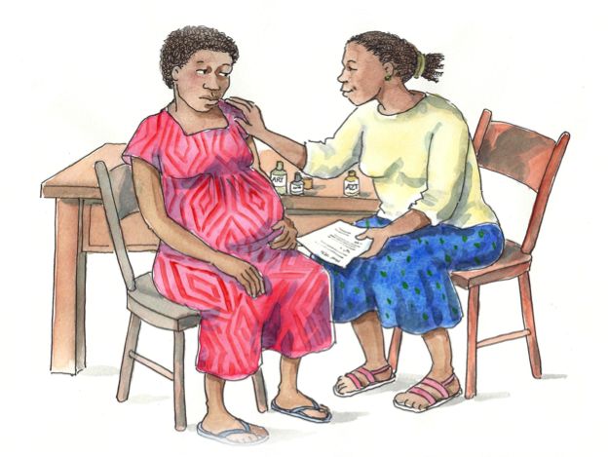

SESSION 6.1:
Counseling Basics

What is counseling?
- Counseling is a two-way communication process that helps people look at their personal issues, make decisions, and plan how to take action.

Counseling includes:
- Establishing supportive relationships
- Having conversations with a purpose (not just chatting)
- Listening carefully
- Helping people tell their stories without fear of stigma or judgment
- Giving correct and appropriate information
- Helping people to make informed decisions
- Exploring options and alternatives
- Helping people to recognize and build on their strengths
- Helping people to develop a positive attitude toward life and to become more confident
- Respecting everyone’s needs, values, culture, religion, and lifestyle

Counseling does NOT include:
- Solving another person’s problems
- Telling another person what to do
- Making decisions for another person
- Blaming another person
- Interrogating or questioning another person
- Judging another person
- Preaching to, or lecturing, another person
- Making promises that cannot be kept
- Imposing one’s own beliefs on another person
- Providing inaccurate information

Why do we do counseling?
- To help people talk about, explore, and understand their thoughts and feelings
- To help people work out for themselves what they want to do and how they will do it
Confidentiality:
In order for clients to trust health workers with their feelings and problems, it is important for them to know that anything they say will be kept confidential. This means that members of the multidisciplinary care team will not tell other people any information about the client, including what the client says or that the client is living with HIV. Confidentiality is especially important in HIV programs because of the stigma surrounding HIV and discrimination against PLHIV in the home, at work, at school, and in the community.

Because multidisciplinary teams take care of clients, sometimes they need to discuss a client’s needs and health status with one another to provide the best care possible.

Statements for Values Clarification Exercise:
- I expect clients to do everything in their power to protect their health.
- I feel comfortable discussing sex and sexuality with clients.
- A woman who knows she has HIV and gets pregnant is irresponsible.
- Health workers should always know which services exist for pregnant women in the community.
- It is usually a waste of time to provide counseling to our clients—they rarely listen.
- The biggest reason pregnant women do not adhere to their ARVs is because they are forgetful.
- If I see that a client is acting irresponsibly, it’s my job to correct her behavior.
- Many people living with HIV have made irresponsible decisions in their lives.
- HIV-infected children are victims.
- Some clients do now know enough to make good decisions for themselves.

Self-Awareness:
Listening and counseling require that the counselor be aware of his or her strengths and weaknesses, as well as his or her fears or anxiety about HIV. All health workers should strive to be self-aware and to understand how others affect them as well as how they affect others.

Being self-aware means knowing yourself, how other people view you, and how you affect other people.

Attitudes and values are feelings, beliefs, and emotions about a fact, thing, behavior, or person.
- For example, some people believe that having multiple sexual partners is okay as long as you practice safer sex, while other people believe that this is wrong.

Prejudices are negative opinions or judgments made about a person or group of people before knowing the facts.
- For example, when a health worker assumes that a person with HIV must be promiscuous or that a miner is probably sleeping around when he is away from home, the health worker is being prejudicial.

Health Workers should always:
- Think about the issues related to their own attitudes, values, and prejudices, and how these can affect their ability to help provide effective counseling and support services to pregnant and postpartum women, families, and children
- Be sensitive to the culture, values, and attitudes of their clients, even if they are different from their own
- Learn as much as they can about the main culture, values, and attitudes of the clients at the facility
- Examine their own values and beliefs in order to avoid prejudice and bias, and make all people feel comfortable and that it is “safe” to talk with them openly and honestly.
Remember: Prejudice, stigma, and negative attitudes drive the HIV epidemic, so we all need to work hard to provide quality, fair, equal, and non-judgmental services to all of our clients!

SESSION 6.2:
Key Counseling and Communication Skills

Skill 1: Use Helpful Non-verbal Communication
- Make eye contact.
- Face the person.
- Be relaxed and open with your posture.
- Sit squarely facing the person. Do not sit behind a desk!
- Dress neatly and respectfully.
- Use good body language—nod your head and lean forward.
- Smile.
- Make the client feel that you have time, greeting the client warmly, and wait for the client to talk when she is ready.
- Do not look at your watch, the clock, or anything other than the person you are counseling.
- Try not to write during a counseling session, unless you are recording key information for the client to take home or for your records. Turn your mobile phone off and never take calls during a counseling session.
Role play: Non-verbal communication

What not to do  Unhelpful non-verbal communication | What to do  Helpful non-verbal communication
Client walks in | Client walks in
Health Worker: Hello. My name is ___. (Health worker is filling in the register from behind a desk, does not look at client) | Health Worker: Hello. My name is ___. (Health worker is filling in the register from behind a desk and looks up at client)
Client: I have some questions about my baby getting HIV. | Client: I have some questions about my baby getting HIV.
Health Worker: Please sit down (speaking in a hurried fashion). What were your questions? (Health Worker still looking at the register) | Health Worker: (Looks at client, stops writing in the register, and moves chair so that it is not behind the desk) Please sit down. What were your questions? (Leans forward, open posture)
Client: Well, I want to do everything I can to prevent my baby from getting HIV. But I’m not sure what I can do. | Client: Well, I want to do everything I can to prevent my baby from getting HIV. But I’m not sure what I can do.
Health Worker: Mm-Hmm. (Does not look up and still filling in the register) | Health Worker: I’m glad you are here. Let’s talk about the ways you can lower the chances that your baby will be HIV-infected. (Looks warmly, yet with concern, at client. Optional: demonstrate appropriate touch)
Client: (Clears throat to get counselor’s attention) | Client: Ok.
Health Worker: Oh sorry (she finally stops writing and looks at watch). Yes, go ahead, you said that you are concerned about your medicines? (Health Worker’s hands are folded, legs crossed and facing away from client, looking across the room with expression suggesting disinterest) | Health Worker: There are many things we can do to protect your baby and make sure you stay healthy. Why don’t you tell me a bit more about how things have been going for you and what you have heard about mother-to-child transmission of HIV. (Health Worker looks at client, leaning forward and not crossing legs)
Client: Well not exactly, I want to know more about how I can protect my baby...Don’t worry, sorry to have bothered you. | Client: (Proceeds to tell her story)

Skill 2: Actively Listen and Show Interest in the Client
It is important for the client to know that she has the counselor’s full attention. Feeling that the counselor is actively listening will encourage the client to share more about her situation.

Active listening skills:
- Listen in a way that shows respect, interest, and empathy.
- Show the client you are listening by saying “mm-hmm” or “aha.”
- Use a calm tone of voice.
- Listen to what the client is saying—do you notice any themes?
- Listen to how client is saying it—do she seem worried, angry, etc.?
- Allow the client to express her emotions. For example, if she is crying, allow her time to do so.
- Never judge or impose your own values on a client.
- Find a private place to talk and keep distractions, such as phone calls or visitors, to a minimum.
- Do not do other tasks while counseling a client.
- Do not interrupt the client.
- Ask questions or gently probe if you need more information. For example, if a client says, “I can’t exclusively breastfeed my baby,” you could ask, “In what way is exclusive breastfeeding a concern for you?”
- Use open-ended questions that can’t be answered with “yes” or “no.” For example, “Can you tell me a bit more about that?”
- Summarize key points as you go during the counseling session.

Role play: Active listening

What to do
Gestures and responses that show interest
Health Worker: How do you think your partner will react if you tell him your HIV test results?
Client: Actually, I’m really very worried about it. I was hoping you wouldn’t ask, to tell you the truth.
Health Worker: Mm-hmm. (nods sympathetically)
Client: I think my husband will accuse me of being unfaithful if he knows I have HIV.
Health Worker: He’ll accuse you of being unfaithful then?
Client: Well, mostly he’ll be angry that I went ahead and agreed to be tested without telling him first. And then he will probably say I was unfaithful.
Health Worker: Mm-hmm.
Client: Last time I was sick and went to the clinic without asking him, he got angry with me for spending the money to see the doctor and get some tests done. I think he’s going to react the same way.
Health Worker: I’m hearing that he may get upset that you got tested without consulting with him first. So, how do you feel about bringing him to the clinic and then one of the counselors he talk with him about how HIV testing is a routine part of care for all pregnant women? And also that HIV testing is important to get the care you and the baby need and why he should you think about that?

Skill 3: Ask Open-ended Questions
Closed-ended questions:
Closed-ended questions can be answered with a one-word or short answer. Examples of closed-ended questions are, “How old are you?” “What is your CD4 count?” and “Do you have children?”

Closed-ended questions are good for gathering basic information at the start of a counseling or group education session. They should not be used too much because they can make it seem like the counselor is being too direct. They are not helpful in getting at how the client is really feeling.

Open-ended questions:
Open-ended questions cannot be answered in one word. People answer open-ended questions with more of an explanation. Examples of open-ended questions are, “Can you tell me more about your relationship with your partner?” or “How does that make you feel?”

Open-ended questions are the best kind to ask during counseling and group education sessions because they encourage the client to talk openly and they lead to further discussion. They help clients explain their feelings and concerns, and also help counselors get the information they need to help clients make decisions.

Role play: Open-ended questions

What not to do  Closed-ended questions | What to do  Open-ended questions
Client walks in | Client walks in
Health Worker: Hi, how are you? I’m ___. I am a nurse. Today, as part of your visit, I will be discussing with you the medicines you need to take to stay healthy and lower the chance that your baby will be infected. | Health Worker: Hi, how are you? I’m ___. I am a nurse. Today, as part of your visit, I will be discussing with you the medicines you need to take to stay healthy and lower the chance that your baby will be infected.
Client: OK | Client: OK
Health Worker: Do you know what ARVs are? | Health Worker: Tell me, what have you heard about ARV medicines?
Client: Yes, I think so. | Client: Well, I’m not sure, but I heard they can make people with HIV feel better. But I also heard they are dangerous for babies.
Health Worker: OK. And do you know that you have to take them at the same time every day? | Health Worker: You are right that ARVs are medicines that can help people with HIV feel better and stay healthy. They can also lower the chance that your baby will be HIV-infected. ARVs are safe for pregnant women and babies. How do you feel about taking ARVs during your pregnancy?
Client: Um, yes, I guess so. | Client: Well, I guess I will do anything to protect my baby. But, how long will I have to take them?
Health Worker: OK, good. So, here are the medicines you need to take every day. Don’t miss any doses, OK? | Health Worker: Well, we recommend that you start taking ARVs now and every day during your pregnancy and your labor and delivery. You can stop taking them one week after you deliver, but you will need to give your baby ARV syrup every day as long as you are breastfeeding. This will protect your baby from HIV.  Tell me, what support do you have at home to take medicines every day and care for your baby?
Client: OK. | Client: Well, my sister helps me and she knows that I have HIV.
Health Worker: See you at your next visit then. | Health Worker: That’s great. What are some of the ways that you think will help you to remember to come back for all of your appointments and to take your medicine every day?
 | Client: Well…(client continues to discuss with health worker)

Additional practice on closed- and open-ended questions:
Closed-ended question | Open-ended question
Do you have safe sex? | How do you negotiate safe sex with your partner?
Do you have more than one sex partner? | There are a lot of ways to reduce risk for HIV— like not having sex, being faithful to your partner, and using condoms. Which would work best for you based on your situation?
Do you use condoms? | What challenges do you have using condoms with your partner?
Do you drink alcohol when you are upset? | What are some of the ways you cope with stress or anger?
Did your partner get tested? | How would you feel about asking your partner to get tested so you can both be as healthy as possible?
Do you want to have children in the future? | How do you feel about having a bigger family? What concerns to do you have?
Do you have someone you can talk with about taking your medicines the right way? | Tell me more about the people you have disclosed to and how they could help you remember to take your medicines.
Do you know how to prevent transmission of HIV to your baby? | I want to make sure that I have explained everything well to you – can you tell me what you understand about ways you can protect your baby from HIV?
Do you exclusively breastfeed your baby? | Can you tell me more about how you feed your baby?

Skill 4: Reflect Back What the Client is Saying
Reflecting skills:
The counselor repeats back to the client the main feelings and themes that the client has just expressed.

Reflecting:
- Provides feedback to the client and lets her know that she has been listened to, understood, and accepted
- Encourages the client to say more
- Shows that the counselor has understood the client’s story
- Helps the counselor check that he or she has understood the client’s story
- Provides a good alternative to always answering with another question
- Can reflect the client’s feelings and include a summary of the content of what the client has said (sometimes called paraphrasing)
- For example, the counselor can use the following formulas for reflecting:
- “You feel ____________ because ____________.”
- “You seem to feel that ___________ because __________.”
- “You think that _____________ because ______________.”
- “So I sense that you feel __________ because __________.”
- “I’m hearing that when ___________ happened, you didn’t know what to do.”
- When reflecting back, try to say it in a slightly different way. Do not just repeat what the client said. For example, if a client says, “I can’t tell my partner about my HIV test result,” the counselor could say, “Talking to your partner about your result sounds like something that you are not comfortable doing.” Then say, “Let’s talk about that”.

Role play: Reflecting skills

What to do
Reflecting back
Health Worker: I’m hearing that you are having some challenges remembering to take your medicines every day. What do you think about telling your partner about your HIV-status? Maybe he could be your treatment supporter?
Client: Well, I honestly don’t think I could ever bring up the subject to him. I think he’d get really angry and say that I have been sleeping around.
Health Worker: It sounds like you could use some extra support, but that disclosing to your husband is something that you would actually be hesitant, maybe even afraid, to do right now.
Client: Yes, that’s right…

Additional Practice on Reflecting:
Reflect back to the following statements:
- I missed a lot of my pills this month and I feel hopeless.
- My boyfriend does not know my test results—I’m scared to tell him.
- I feel like a bad mother because my baby does not want to suckle from me.
- My husband would just get angry if I asked him to use a condom, so I am not going to ask.
- My husband thinks it’s dangerous to give the baby medicines and I am afraid of disobeying him.
- I am worried because my mother-in-law will assume I am living with HIV if I don’t give the baby herbs.
- I feel so happy that my baby is growing well.
Skill 5: Empathize—Show That You Understand How the Client Feels
Empathy or empathizing:
- Is a skill used in response to an emotional statement
- Shows an understanding of how the client feels and encourages the client to discuss the issue further
- Is different than sympathy. When you sympathize, you feel sorry for a person and look at the situation from your own point of view. For example, if the client says: “My baby wants to feed very often and it makes me feel so tired,” the counselor can show empathy by saying: “You are feeling very tired all the time then?” However, if the counselor responds by saying, “I know how you feel. My baby also wanted to feed often and I was exhausted!,” this is sympathizing because the attention is on the counselor and her experiences instead of on the client.

Role play: Showing empathy vs. sympathy
What not to do  Sympathizing | What to do  Empathizing
Health Worker: What do you think about asking your partner to use condoms while you are breastfeeding? | Health Worker: What do you think about asking your partner to use condoms while you are breastfeeding?
Client: I’d be really afraid that he might hit me, or even worse. | Client: I’d be really afraid that he might hit me, or even worse.
Health Worker: Yes, I know what you mean, that happened to my sister. She actually did ask her husband to use condoms after the baby and you know what? He hit her then he made her leave the house. He didn’t let her come back for two full days. | Health Worker: It sounds like you’re afraid of your husband’s response.
Client: So did your sister go back? | Client: Yes, I am. It’s not just about asking him to use condoms. I’m also scared that he’ll be upset if dinner is late, if the house isn’t tidy, if the children aren’t behaving well, and for a lot of other reasons.

Skill 6: Avoid Words That Sound Judging
Judging words are words that can include:
- “right”: You should do the right thing.
- “wrong”: That is the wrong way to feel.
- “badly”: Why are you behaving badly and missing appointments?
- “good”: Be a good girl and tell your boyfriend to use condoms.
- “properly”: Why don’t you take your medicine properly?
- “these people” or “those people” (referring to people living with HIV for example): Those people are irresponsible and should not have children.

If a counselor uses these words when asking questions, the client may feel that she is wrong, or that there is something wrong with her actions or feelings. Sometimes, however, counselors need to use the “good” judging words to build a client's confidence.

Role Play: Avoiding judging words

What not to do  Using judging words | What to do  Avoid words that sound judging
Health Worker: What do you think about asking your partner to use condoms during your pregnancy? | Health Worker: What do you think about asking your partner to use condoms during your pregnancy?
Client: Honestly I don’t feel comfortable with it. | Client: Honestly I don’t feel comfortable with it.
Health Worker: (Surprised) Really? That’s the wrong way to feel! Have you had a conversation about condoms? | Health Worker: Mm-hmm.
Client: No, not really. | Client: It came up once many years ago before we got married. He said that condoms were uncomfortable and will give him kidney problems.
Health Worker: He’s stupid, isn’t he? I guess he doesn’t care about you or the baby. Typical man. Be a good, responsible woman and talk with him about condoms—he should care more about his baby. | Health Worker: I’ve heard other women say that as well. Maybe, now that you are pregnant, you could try talking to him again—about using condoms to protect the baby’s and your health? Also, condoms definitely won’t cause any kidney problems, that is a myth.
Client: Yes, I will. | Client: That’s a good idea, maybe I’ll try that.

Skill 7: Help the Client Set Goals and Summarize Each Counseling Session
Goal-setting:
Toward the end of a counseling session, the counselor should work with the client to come up with “next steps” to solve her issues in the short and long term.

Next steps and goals:
- Should be developed by the counselor and client together
- Can empower the client to achieve what she wants by agreeing to realistic short- and long-term goals and actions
- Provide direction and must be results-oriented
- Must be clear enough to help the client measure her own progress (people feel good when they achieve something they have set out to do)
- To start, the counselor could say, “Okay, now let’s think about the things you will do this week based on what we talked about.”

Summarizing:
The counselor summarizes what has been said during a counseling session and clarifies the major ideas and next steps.

Summarizing:
- Can be useful in an ongoing counseling session or in making sure you are clear on important issues raised during a counseling session
- Is best when both the counselor and client participate and agree with the summary
- Provides an opportunity for the counselor to encourage the client to examine her feelings about the session
- The counselor could say, “I think we’ve talked about a lot of important things today. (List main points.) We agreed that the best next steps are to ___________________. Does that sound right? Let’s plan a time to talk again soon.”

The Phases of a Counseling Session

4 Phases of a Counseling Session

1. Establishing the Relationship
2. Understanding the Problem
3. Supporting Decision-Making
4. Ending the Session

1. Establishing the Relationship
- The room should be quiet with doors that close and where there are no interruptions.
- Introduce yourself: Say your name and explain your role and the length of time you have together (i.e. half an hour).
- Ask the client to introduce herself or himself.
- Explain that what is discussed will be kept confidential.
- Ways to begin a counseling session:
- Can you tell me why you came here today?
- Where would you like to start?

2. Understanding the Problem
- Let the client talk about the thoughts, feelings, and actions around her or his issues or problems.
- Use the 7 essential counseling and communication skills.
- Help the client decide which issues or problems are the most important to talk about in the session.

3. Supporting Decision-Making
- Support the client to make her or his own decisions on next steps and focus for the future.
- The health worker can help the client explore the options, but it is ultimately the client’s decision to make.

4. Ending the Session
- Summarize what was discussed during the session.
- Review the client’s next steps.
- Give the client a chance to ask questions.
- Make referrals, if needed.
- Discuss when the client will return and make sure she or he has an appointment.

SESSION 6.3:
Classroom Practicum

Case Studies:

Case Study 1:
M___ is at the ANC clinic for the first time. She is 16 and lives with her aunt. M___ is still in school, and just found out that she is pregnant and HIV-infected. She is concerned that being pregnant and having HIV will mean giving up her dream of becoming a nurse.

Case Study 2:
P___ is pregnant with her first baby and has found out she has HIV. P___’s husband is the boss of the house. She says she is so frightened that her husband might find out when he sees the medicines from the clinic.

Case Study 3:
D___ is enrolled in the PMTCT program and started taking ART about 4 months ago. She starts crying because she was not able to get enough money to pay for the bus to the clinic last month, so she has stopped taking her ARVs. D___ is very worried because she has no job, no money, and now she is feeling unwell.

Case Study 4:
L___ is living with HIV. She is enrolled in the PMTCT program and had her second child about 7 weeks ago. Her first child is HIV-uninfected. She comes to the clinic today to get her new baby tested for HIV. She is very worried that the baby is HIV-infected because he is sick a lot of the time.

SESSION 6.4:
Module Summary

THE KEY POINTS OF THIS MODULE INCLUDE:

- Counseling is a way of working with people to understand how they feel and help them decide what they think is best to do in their situation.
- Health workers are not responsible for solving all of the client’s problems.
- The role of health workers is to support and assist the client’s decision-making process.
- It is important for clients to know that what they say will be kept private. All health workers should practice shared confidentiality.
- The multidisciplinary care team should work to ensure that there is private counseling space available and that counseling sessions are not interrupted for any reason.
- Our own attitudes, values, and prejudices should not be a part of communication and counseling with clients and other community members.
- These are the 7 key counseling and communication skills health workers should use:
- Use helpful non-verbal communication.
- Actively listen and show interest in the client.
- Ask open-ended questions.
- Reflect back what the client is saying.
- Empathize—show that you understand how the client feels.
- Avoid words that sound judging.
- Help the client set goals and summarize each counseling session.
- There are 4 main phases of a counseling session:
- Establishing the relationship
- Understanding the problem
- Supporting decision-making
- Ending the session
- There can be many challenges to providing quality counseling in PMTCT and ART clinics, including lack of time and lack of private counseling space.
- Improving counseling skills takes practice, as well as continuous self-exploration of our own values and attitudes.

Appendix 6A:
Counseling and Communication Skills Checklist
Counseling and Communication Skills Checklist
Skill | Specific Strategies, Statements, Behaviors | (√)
Establish a relationship with the client | - Ensure privacy (make sure others cannot see or hear).
Establish a relationship with the client | - Introduce yourself (name and role).
Establish a relationship with the client | - Ask the client to introduce herself (or himself) to you.
Establish a relationship with the client | - Ensure client about confidentiality.
Establish a relationship with the client | - Start the session with an open-ended question (“Where would you like to start?” or “Tell me more about why you came today.”)
Skill 1: Use helpful non-verbal communication | - Make eye contact.
Skill 1: Use helpful non-verbal communication | - Face the person (sit next to her or him) and be relaxed and open with posture.
Skill 1: Use helpful non-verbal communication | - Use good body language (nod, lean forward, etc.).
Skill 1: Use helpful non-verbal communication | - Smile.
Skill 1: Use helpful non-verbal communication | - Do not look at your watch, the clock or anything other than the client.
Skill 1: Use helpful non-verbal communication | - Do not write during the session.
Skill 1: Use helpful non-verbal communication | - Other (specify)
Skill 2: Actively listen and show interest in your client | - Nod and smile. Use encouraging responses (such as “yes,” “okay” and “mm-hmm”).
Skill 2: Actively listen and show interest in your client | - Use a calm tone of voice that is not directive.
Skill 2: Actively listen and show interest in your client | - Allow the client to express emotions.
Skill 2: Actively listen and show interest in your client | - Do not interrupt.
Skill 2: Actively listen and show interest in your client | - Other (specify)
Skill 3: Ask open-ended questions | - Use open-ended questions to get more information.
Skill 3: Ask open-ended questions | - Ask questions that show interest, care and concern.
Skill 3: Ask open-ended questions | - Other (specify)
Skill 4: Reflect back what your client is saying | - Reflect emotional responses back to the client.
Skill 4: Reflect back what your client is saying | - Other (specify)
Skill 5: Show empathy, not sympathy | - Demonstrate empathy: show an understanding of how the client feels.
Skill 5: Show empathy, not sympathy | - Avoid sympathy.
Skill 5: Show empathy, not sympathy | - Other (specify)
Skill 6: Avoid judging words | - Avoid judging words such as “bad,” “proper,” “right,” “wrong,” etc.
Skill 6: Avoid judging words | - Use words that build confidence and give support (e.g., recognize and praise what a client is doing right).
Skill 6: Avoid judging words | - Other (specify)
Skill 7: Help your client set goals and summarize each counseling session | - Work with the client to come up with realistic “next steps.”
 | - Summarize the main points of the counseling session.
 | - Make a next appointment date with the client and reassure her or him that you, or someone else at the clinic, are always available.

Note: This checklist was adapted from: WHO & CDC. Prevention of Mother-to-Child Transmission of HIV Generic Training Package: Trainer Manual. 2008.
Appendix 6B:
Optional Homework/Review of Counseling and Communication Skills

INSTRUCTIONS:
Please answer the following questions. Refer to the Key Information from Supplemental Module 6 if you need additional help or a refresher.

- Why is non-verbal communication important? What are some ways to show good non-verbal communication?

- Why is active listening important? What are some ways a counselor can show she or he is actively listening to the client?

- What is the difference between closed- and open-ended questions?

- Change the following into open-ended questions:

- Do you use condoms?

- Did you take all of your medicines?

- Did you tell someone about your HIV test results?

- Do you have support at home to give the baby medicines?

- Are you having any side effects?

- Do you know you need to come back to the clinic in 4 weeks time?

- Did you get your CD4 test results?

- Are you breastfeeding?

- Why is reflection important? What are some of the formulas for reflection?

- Reflect back the following statements:

- I missed a lot of my pills this month and I feel hopeless.

- My boyfriend does not know my test results—I’m scared to tell him.

- I feel like a bad mother because my baby does not want to suckle from me.

- My husband would just get angry if I asked him to use a condom, so I am not going to ask.

- My husband thinks it’s dangerous to give the baby medicines and I am afraid of disobeying him.

- I am worried because my mother-in-law will assume I am living with HIV if I don’t give the baby herbs.

- I feel so happy that my baby is growing well.

- What is the difference between showing empathy and showing sympathy?

- How would you use reflection and show empathy if your client said the following:

- I am so dizzy and weak since I started taking these pills. I am going to stop.

- My milk looks so thin. I am worried it isn’t enough for the baby.

- I am really scared to tell my boyfriend I have HIV.

- I will be so sad if my baby has HIV.

- I have to hide my medicines so it is hard for me to remember to take them at the right times.

- What are the key parts or phases of a counselling session? Why is each phase important?

Improving Retention, Adherence, and Psychosocial Support within PMTCT Services

Implementation Workshop Curriculum for
Health Workers

Thank you for participating!

